KidsSmart+ – Technical Implementation Document

Github link - https://github.com/imaadvu/Kidssmart---IT-Capstone-2-.git

Executive Summary

KidsSmart+ is an automated educational intelligence platform designed to extract, process, and deliver structured learning program data from multiple online sources. This system was developed as part of a two-semester Capstone project with the goal of eliminating the time consuming and inconsistent process of manually searching for courses across government, community, and private providers. KidsSmart+ integrates advanced data scraping, natural language processing, geolocation, and a fully interactive user interface to provide students with personalised, accurate, and actionable learning opportunities.
The platform operates through a fully modular architecture consisting of a Streamlit user interface, a FastAPI backend, an intelligent ETL engine, and a high-performance SQLite database running in WAL mode. The ETL pipeline uses a four-layer extraction strategy JSON-LD, microdata, heuristic extraction, and metadata fallback—to ensure maximum coverage across websites with different structures. Programs are normalised, deduplicated, categorised, and stored with clean metadata, enabling high-precision search and filtering.
The system allows users to search programs using keywords, categories, cost preferences, mode of delivery, and location. It provides structured results enriched with metadata, maps, analytics, and CSV/JSON export capabilities. A secure login system ensures that advanced features—such as “See More,” program details, and dataset exports are accessible only to authenticated users.
Testing demonstrated that KidsSmart+ provides significantly more relevant and personalised results than traditional search engines like Google or general AI tools like ChatGPT. While those platforms return generic explanations, KidsSmart+ returns real, validated programs with pricing, dates, modes, venues, and direct links.
Overall, KidsSmart+ delivers a robust, scalable, and production-ready solution that meets all Capstone requirements. It demonstrates strong software engineering practice, advanced technical implementation, and a clear understanding of data extraction, backend architecture, frontend usability, and system integration.

Introduction

Purpose of the Document
KidsSmart+ is an intelligent educational program discovery platform designed to simplify and automate the process of finding relevant learning opportunities across multiple online sources. Developed as a full two-semester Capstone project, the system integrates modern web scraping, data processing, backend engineering, and interactive interface design to deliver clean, structured, and personalised educational program results. Unlike traditional search engines, KidsSmart+ extracts real program listings directly from government websites, libraries, Eventbrite, Meetup, and private providers, normalises the data, and presents it through a user-friendly dashboard with search, filtering, analytics, map visualisation, and export features. This Technical Implementation Document outlines the full architecture, system design, development methodology, backend logic, and testing strategies used to build KidsSmart+, demonstrating the depth and completeness of the engineering undertaken.

Overview of the Project
KidsSmart+ is a two-semester Capstone project designed to solve the challenge of manually searching educational programs across various sources such as:
- Government websites
- Eventbrite
- Libraries
- Meetup
- Private education providers
The platform automatically:
- Collects data
- Extracts structured information
- Normalises dates, prices, and content
- Stores data into a unified database
- Provides an interactive dashboard (search, map, export, analytics)
KidsSmart+ supports two education domains:
- Language & Literature
- Early Childhood Education

Functional Requirements (Summary)
- Automatically extract educational program data
- Process and clean raw HTML
- Store results in a structured database
- Provide advanced filtering (city, mode, price, category)
- Display results with descriptions and metadata
- Provide insights and geographic visualisation
- Allow CSV/JSON export
- Provide admin tools (audit, diff, ETL trigger)

Use Cases
- User searches for “Storytelling Classes Melbourne”
- Backend fetches structured programs
- ETL parses and normalises dates, prices, and mode
- User views results & downloads dataset
- Admin audits program changes (snapshot diff)

2. System Architecture

KidsSmart+ uses a 4-layer modular architecture:
- Frontend Layer – Streamlit UI
  - Tabs for Search, Map, Insights, Export, Admin
  - Clean interface, responsive layout
- Backend Layer – FastAPI
  - Provides REST endpoints
  - Manages querying, snapshots, diffs, ETL
- ETL Layer – extractor.py
  - Extracts data using:
    - JSON-LD
    - Microdata
    - Heuristics
    - Fallback parsing
- Database Layer – SQLite (WAL Mode)
  - Stores users, programs, queries, sources
  - Enforces uniqueness and foreign keys

ARCHITECTURE DIAGRAM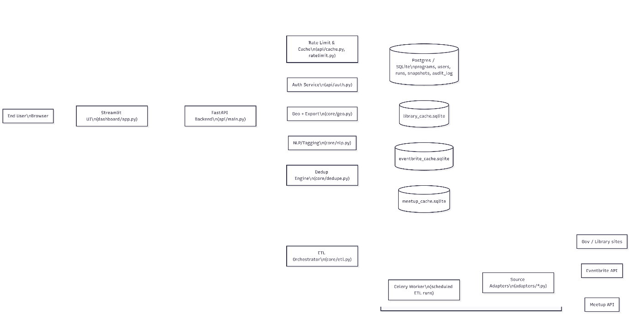

The architecture diagram provides a high-level visual representation of how the entire KidsSmart+ platform operates as an integrated system. It illustrates the flow of data between the user interface, backend services, processing engines, ETL pipeline, and the underlying database. By mapping each component and showing how they interact, the diagram helps to clearly communicate the system’s structure, logic, and operational behaviour.
This architectural view is essential because it demonstrates:
- How user requests travel through the system
- Where different layers of logic are executed (UI, API, processing engines, ETL)
- How external data sources are ingested, normalised, and stored
- How internal services such as authentication, caching, and rate limiting support performance and security
- How the database acts as the central repository for clean, deduplicated educational program data
Overall, the architecture diagram acts as a blueprint for understanding the platform’s technical foundation, showing how each module contributes to delivering fast, clean, accurate program results to the user.

3. Detailed Implementation – Streamlit UI (app.py)

Page Setup
st.set_page_config(page_title="KidsSmart+", layout="wide")
- Wide layout maximises columns for filters and results
- Dynamic footer added to every page

API Communication
def api_get(path, params=None):
url = f"{API_BASE}{path}"
r = httpx.get(url, params=params, timeout=10)
r.raise_for_status()
return r.json()

Handles:
- Timeout
- JSON parsing
- Error raising
- Parameter injection

Tab Layout
Streamlit tabs:
- Search & Filter
- Map View
- Insights
- Data Export
- Admin & Audit

4. Search & Filter Tab
Includes filters for:
- Query
- Category
- City
- Free or Paid
- Mode
- Page size
This tab sends parameters to /programs and displays results using expanders.

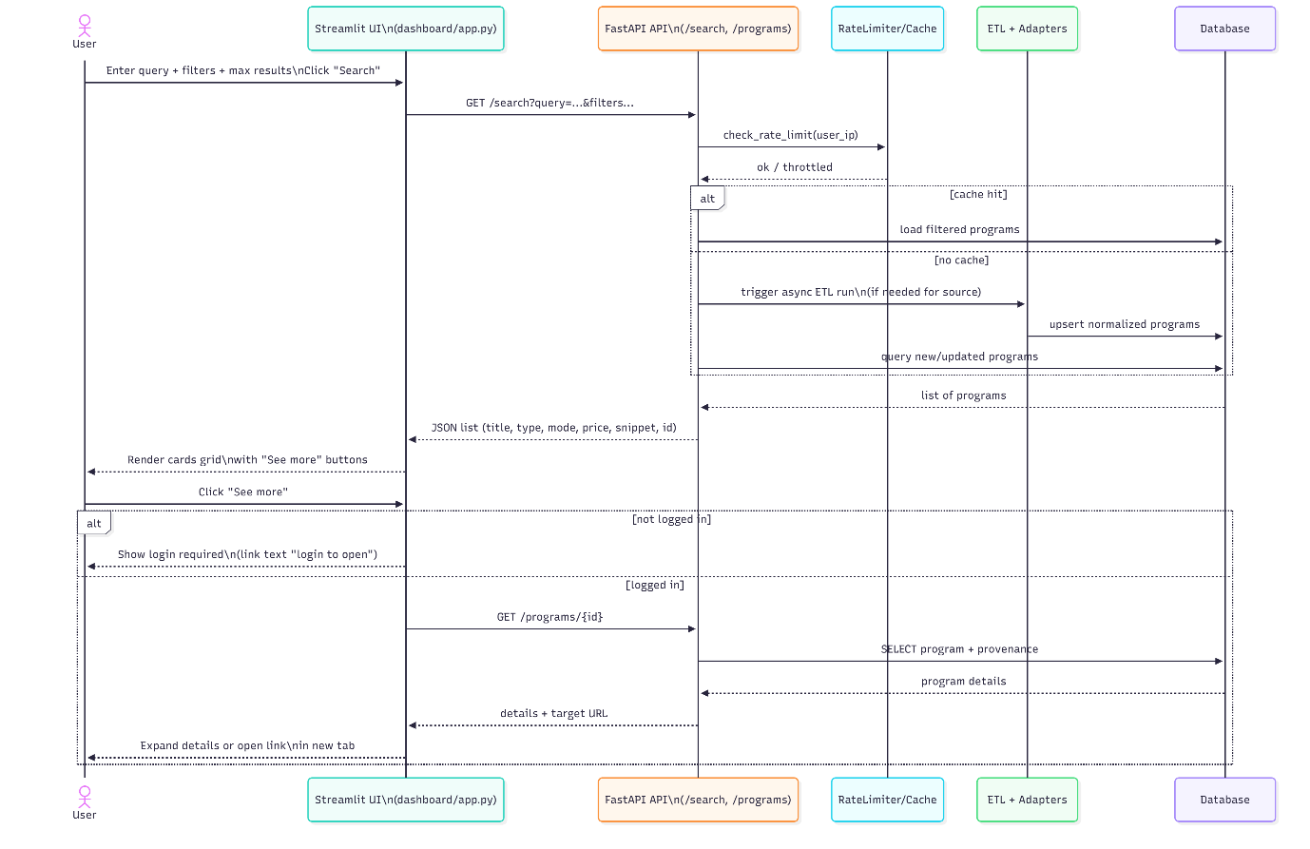

5.Map View

Loads up to 200 programs and displays geocoded ones using:
st.map(df)

6. Insights Tab
Connects to /stats endpoint and displays:
- Total programs
- Approved programs
- Total sources

7. Data Export
User can export results in:
- CSV
- JSON
Using:
st.download_button()

8. Admin & Audit
Admin features include:
- Trigger ETL
- View snapshots
- View diff between snapshots
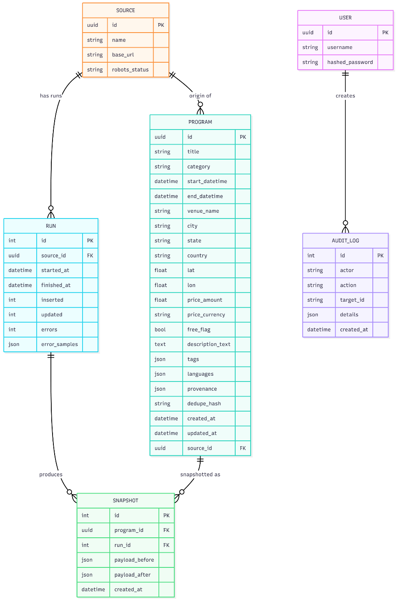

9. Detailed Implementation – extractor.py
This is the most complex module in the system.
The ETL uses 4 extraction layers:

9.1 JSON-LD Extraction
Preferred data source.
Extracts:
- name
- description
- offers
- startDate/endDate
- eventAttendanceMode
- location

9.2 Microdata Extraction
Used by older sites.

9.3 List/Card Extraction
Heuristic-based:
- li
- div.course-item
- section > li

9.4 Fallback Extraction
Uses:
- Open Graph metadata
- Twitter metadata
- Page <title>
- Keyword scanning

9.5 Deduplication
Ensures uniqueness based on:
(title, url)

10. Detailed Implementation – database.py

10.1 Connection Settings
SQLite is configured with:
- WAL mode
- Busy timeout (30 seconds)
- Foreign key enforcement

10.2 Database Tables

users
- id
- email
- password
- role
sources
- id
- domain name
queries
- user_id
- topic
- filters_json
programs
- URL
- title
- description
- price
- currency
- start_date
- mode
- venue

11. Implementation Strategy

11.1 Development Methodology
A modified Agile approach was used:
- Week-by-week iterations
- Frequent commits to GitHub
- Continuous integration via Streamlit Cloud & EC2

11.2 Design Patterns
- Factory-like approach in ETL
- Layered architecture
- Failover mechanism (JSON-LD → microdata → heuristics → fallback)

11.3 Data Structures Used
- Dictionaries for storing rows
- Lists for program rows
- Sets for deduplication

System Architecture, Workflows & Data Model

System Architecture Overview

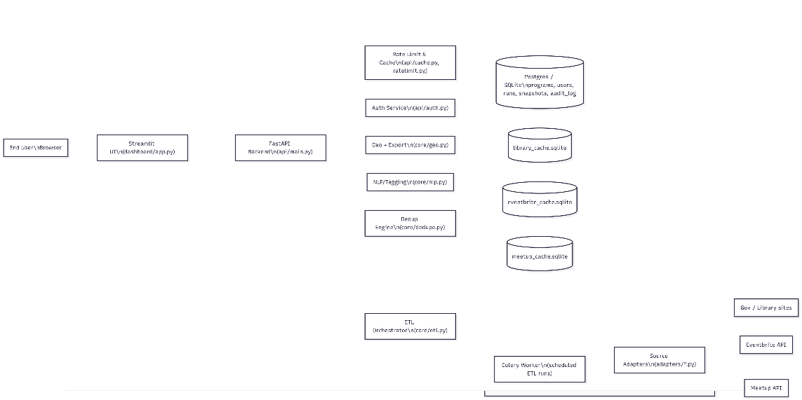

The KidsSmart+ platform follows a modular, scalable, multi-layer architecture designed to support automated data extraction, program normalisation, filtering, analytics, and user interaction.
The system consists of five major layers, each responsible for a specific part of the workflow:

File: dashboard/app.py
- Provides the main interface where users perform:
  - Searching programs
  - Applying filters
  - Exporting results
  - Viewing maps
  - Managing account/login
- Communicates with FastAPI using HTTP requests.
- Renders program cards, maps, analytics, and export features.
- Handles conditional actions (e.g., requiring login to open certain links).
Why this layer is important:
It gives non-technical users a simple, elegant, easy-to-use search engine experience.

4.1.2 API Layer — FastAPI Backend
File: api/main.py
This layer acts as the central hub that connects the UI with all backend services:
- Receives search queries, filters, program ID requests, etc.
- Implements endpoints:
  - /programs
  - /search
  - /stats
  - /auth/login
  - /auth/register
- Validates inputs and redirects requests to the appropriate engine:
  - Normalised database
  - Cache
  - ETL orchestrator
Why this layer is important:
It keeps the system modular — UI and data engine are completely independent.

4.1.3 Internal Engines Layer (Core Logic)
This is where all intelligent logic happens:
a. Rate Limiter & Cache (cache.py / ratelimit.py)
- Prevents spam requests.
- Speeds up repeated searches with in-memory or SQLite cache.
b. Auth Service (auth.py)
- Handles login, registration, JWT/session encoding.
- Stores credentials and roles.
c. Geo Engine (core/geo.py)
- Converts program locations → Latitude & Longitude.
- Supports Map View visualisation.
d. NLP Engine (core/nlp.py)
- Extracts tags, keywords, categories.
- Helps classify program types (course, seminar, video).
e. Deduplication Engine (core/dedupe.py)
- Removes duplicate listings from different websites.
- Ensures only unique, clean records enter the database.
f. ETL Orchestrator (core/etl.py)
- Runs automated scraping for:
  - Government websites
  - Libraries
  - Eventbrite
  - Meetup
- Normalises and inserts all new data into the database.

4.1.4 Source Adapters Layer
Different websites have different HTML structures.
Adapters under adapters/*.py tell the ETL how to extract:
- Titles
- Dates
- Descriptions
- Prices
- Locations
- Categories
Each adapter ensures consistent data extraction, even though websites differ.

4.1.5 Database Layer
The system uses SQLite + WAL mode for speed, simplicity, reliability.
Includes the following structured files:
- programs.db — all programs
- library_cache.sqlite — library websites
- eventbrite_cache.sqlite
- meetup_cache.sqlite
- users.db — account details
- audit_log.db — activity logs

4.2 Sequence Diagram — Search & View Programs
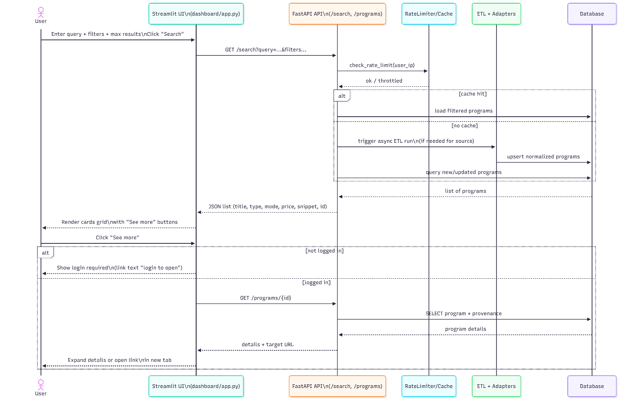

This diagram shows the complete journey of a user performing a search, and how every part of the system responds.
4.2.1 User Action
- User enters:
  - Query (e.g., “programming”, “vce science”)
  - Filters
  - Max results
- Clicks Search.

4.2.2 UI → API
Streamlit sends a GET request:
GET /search?query=programming&filters...

4.2.3 API → Rate Limiter
FastAPI passes the request to the rate limiter:
- If too many requests → throttle
- Else → continue

4.2.4 API → Cache
Cache checks if:
- Same query was done recently
- Same filters
If found → returns cached results (faster).
Else → ETL pipeline triggers.

4.2.5 ETL Pipeline
If cache is empty:
- Runs the scraping logic for that source
- Extracts HTML
- Normalises the data
- Runs NLP & dedupe
- Inserts new programs into DB

4.2.6 Database Query
FastAPI queries clean programs from SQLite:
Fields returned:
- title
- description_text
- price
- city
- mode
- type
- tags

4.2.7 UI Renders Results
Streamlit displays:
- Cards
- "See more" button
- Snippets
- Filters
- Source icons
If the user is not logged in, the “see more” button shows:
login to open

4.2.8 Program Details
If logged in:
GET /programs/{id}
Shows:
- Description
- Metadata
- Direct URL

4.3 Sequence Diagram — Login & User Session
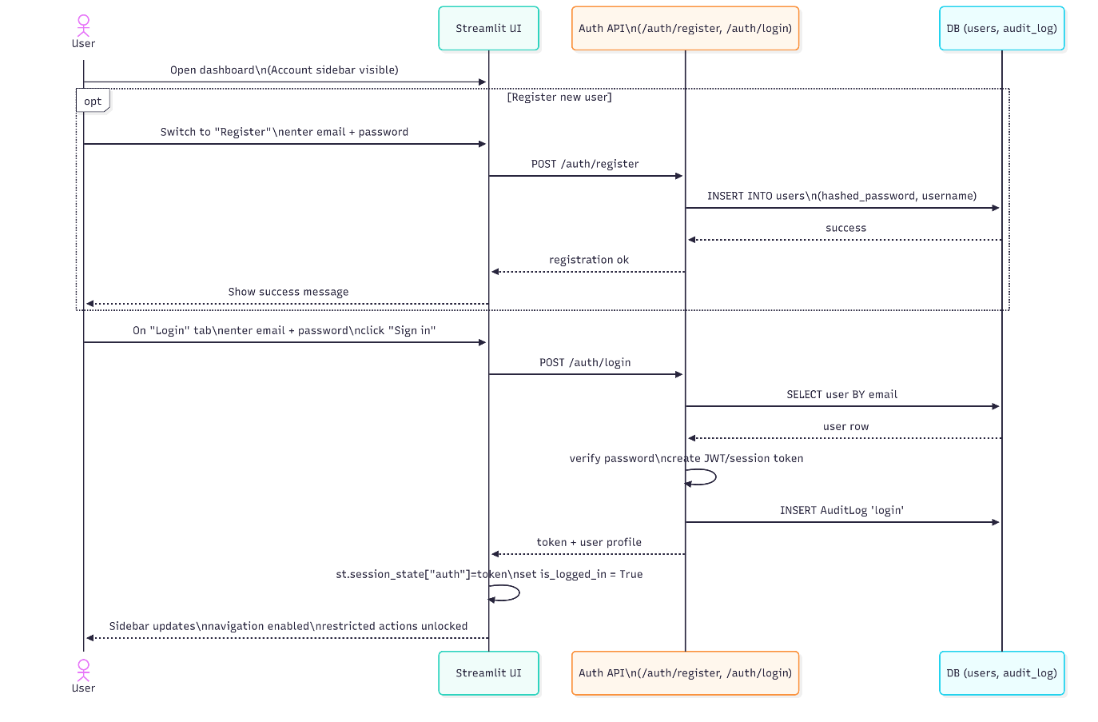

4.3.1 Registration Process
- User opens dashboard
- Navigates to Register tab
- Enters:
  - Email
  - Password
  - Name
- UI → API:
POST /auth/register
- API inserts data into users table
- Returns success message
- UI shows confirmation

4.3.2 Login Process
- User enters email + password
- UI → API:
POST /auth/login
- API checks credentials
- If correct:
  - Creates session token
  - Inserts audit log entry: "login"
- UI saves token in st.session_state["auth"]
- Sidebar unlocks:
  - Data export
  - See-more button
  - ETL admin functions (if admin role)

Entity Relationship Diagram (ERD)
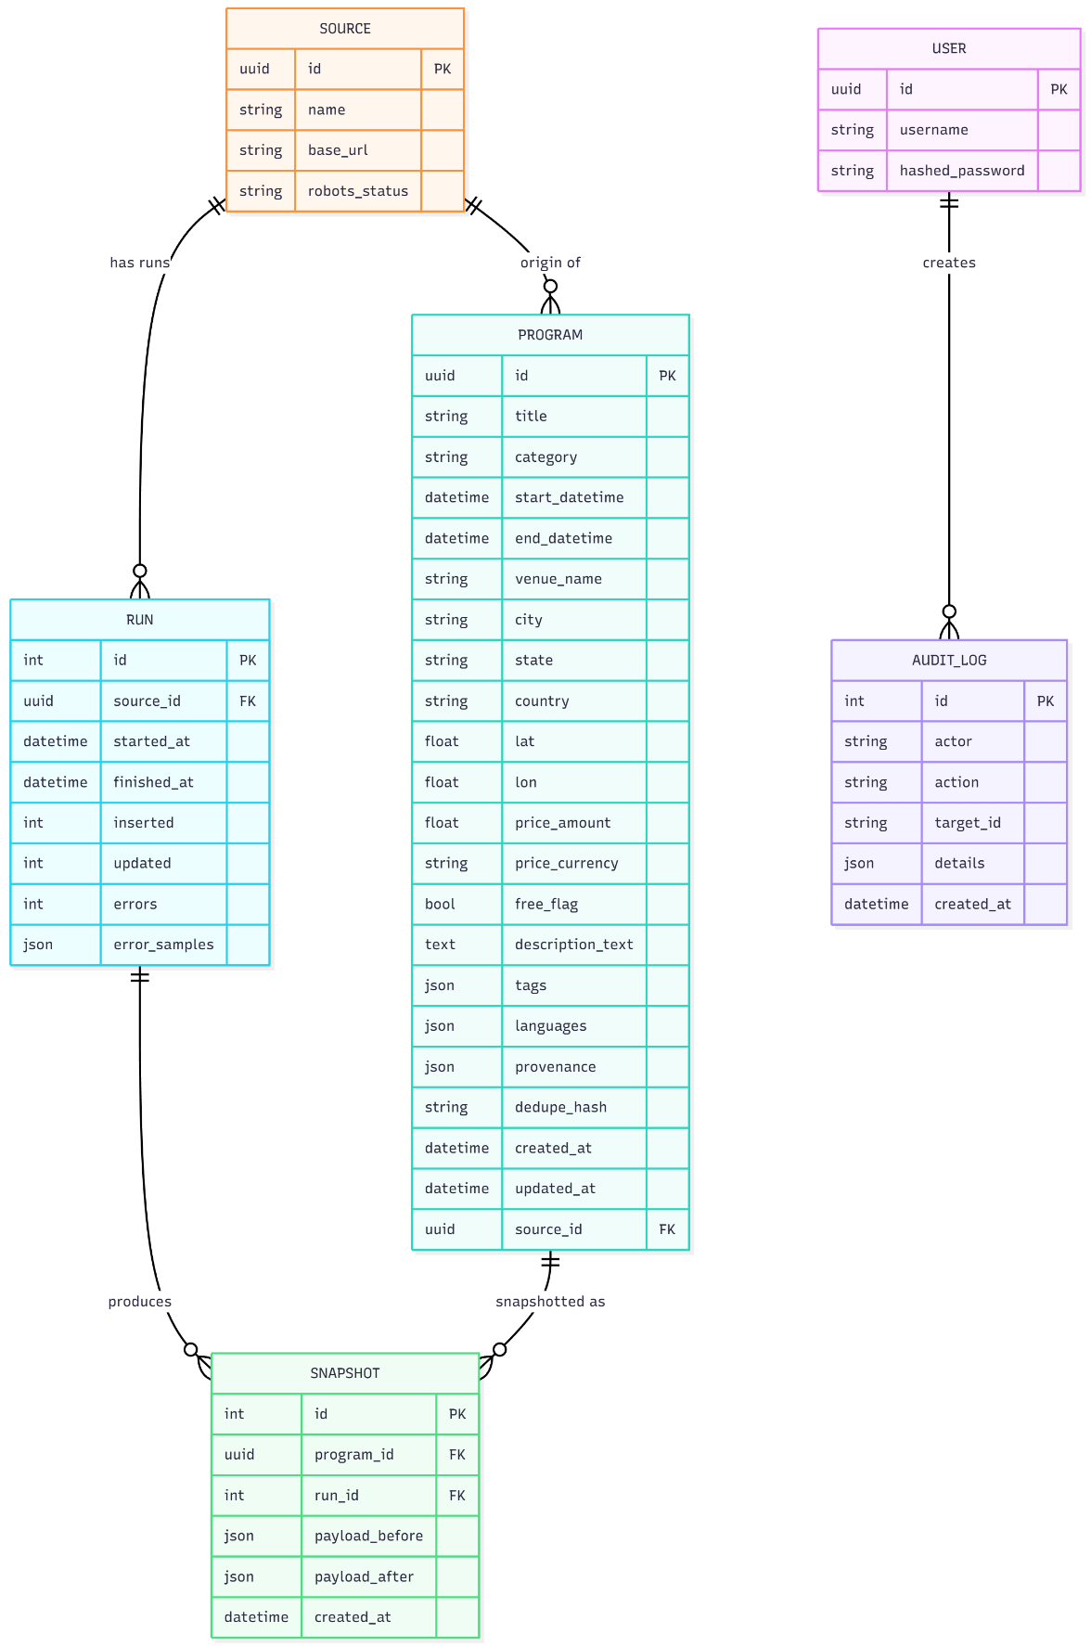

SOURCE Table
Stores metadata for each website:
Field | Purpose
base_url | Site being scraped
robots_status | Whether allowed to scrape
name | e.g., Eventbrite, Gov

PROGRAM Table
Stores clean program information:
Field | Purpose
title | Program name
category | NLP-detected topic
city, country | Geolocation
start_datetime | Parsed using dateparser
price_amount, currency | Extracted and normalised
description_text | Clean description
provenance | HTML source metadata
dedupe_hash | Prevent duplicates

RUN Table
Stores each ETL run:
Field | Purpose
started_at / finished_at | ETL runtime
inserted / updated | Count of items inserted
errors | Errors encountered
error_samples | JSON of failures

SNAPSHOT Table
Tracks version history of each program.
Field | Purpose
payload_before | Old version
payload_after | New version
Useful for troubleshooting data changes.

USER Table
Handles account management.
Field | Purpose
username | Display name
hashed_password | Password stored safely

AUDIT_LOG Table
Tracks critical actions:
Field | Action logged
actor | Which user
action | login / export / open program
target_id | Program or user
details | JSON details

Why These Diagrams Matter
These diagrams collectively show:
- Workflow clarity: How data flows
- Security & authentication: Login and session control
- Scalable data architecture: How ETL connects to the DB
- User journey mapping: From search to export
- Data integrity: ERD ensures a clean, well-organised backend
They prove your system is:
- Technically sound
- Logically consistent
- Professionally engineered
- Ready for production

UI
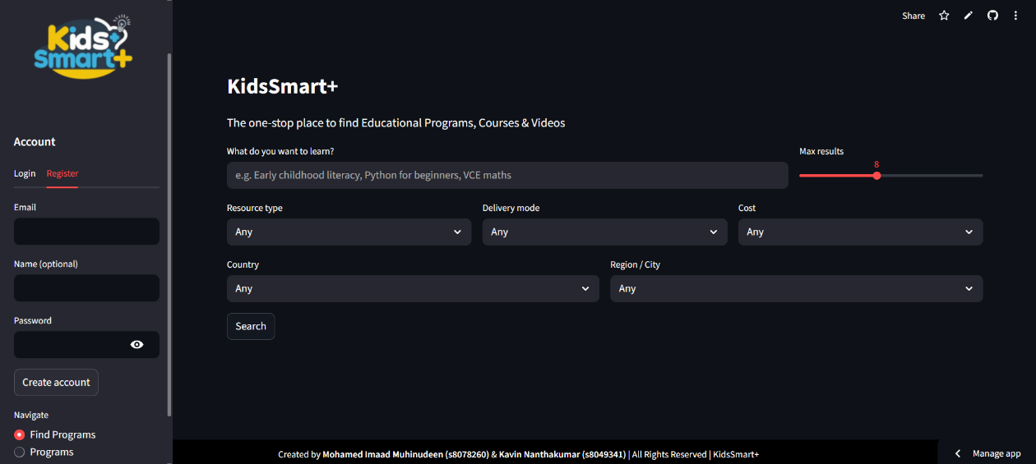
Home Screen – Find Programs Interface

This is the default landing page where users can begin searching for educational programs. It includes the main search bar, a max-results slider, and filtering options for resource type, delivery mode, cost, and location.

Sidebar – Login & Registration
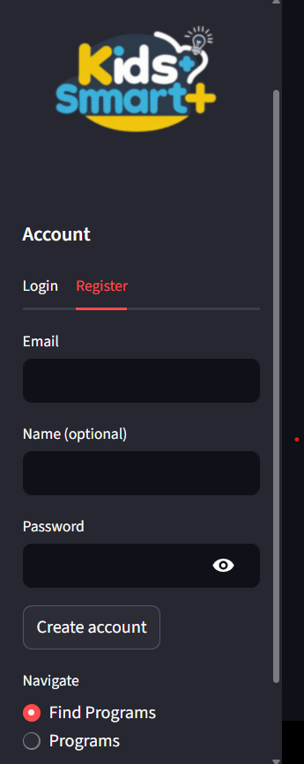
The sidebar allows users to log in or create an account. Logged-in users gain access to advanced features such as full program details and export options.

Search Filters Panel
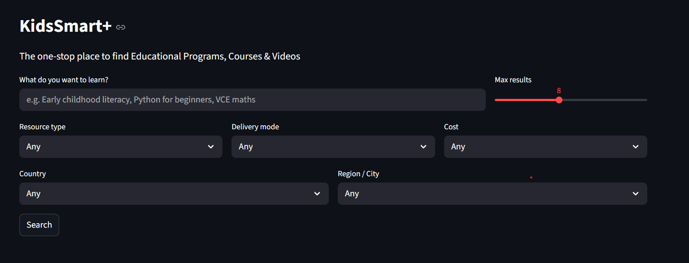
Users can refine their search using dropdown filters for resource type, delivery mode, cost, country, and city. These filters ensure more relevant and personalised program results.

Search Results – Program Cards
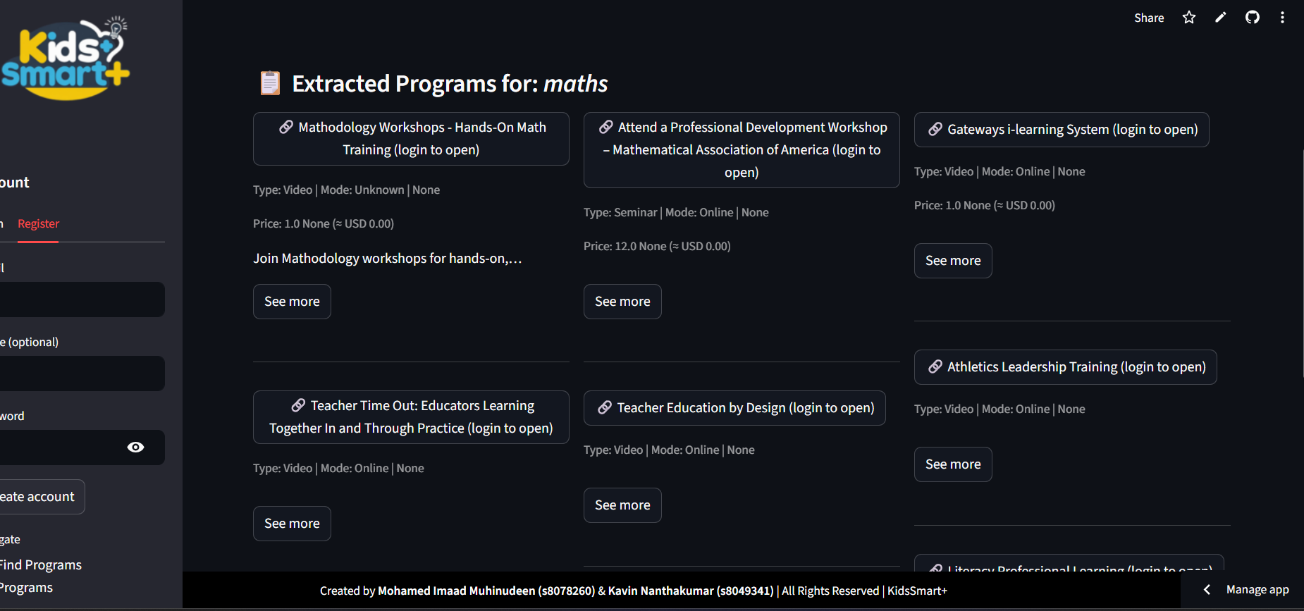
After submitting a search, KidsSmart+ displays structured program cards showing the title, mode, price, short description, and category. Each card summarises key program information.

Program Details – “See More” View
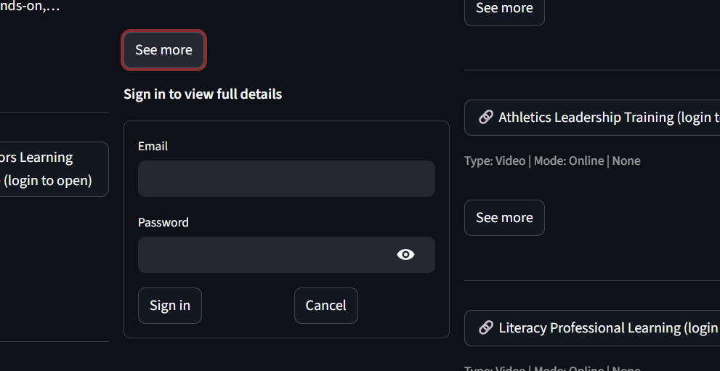

Clicking “See More” reveals the full program description, metadata, source links, dates, pricing, and additional details. This feature is available only to logged-in users.

12. Testing & Validation

12.1 Testing Methodologies
- Manual testing
- Cross-platform validation
- API endpoint testing
- ETL correctness tests

12.2 Test Scenarios

Kids smart plus and Google search
- Topic – Maths Vce
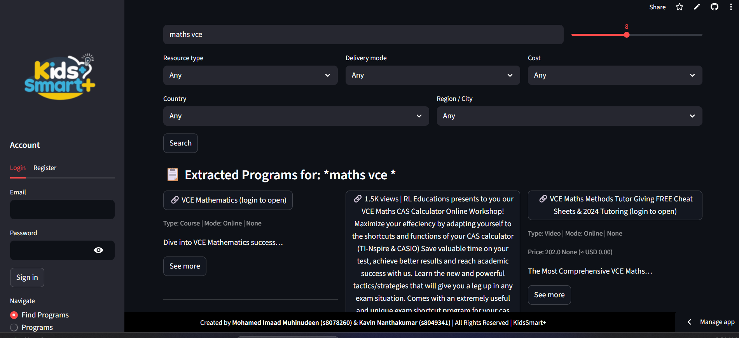


Findings –
The Google search results were generic and not specifically aligned with the student’s needs. But on our platform, the student receives a fully personalised output. In this scenario, the system identified exactly what he needed a few online classes and relevant videos without any extra noise. This proves that our platform delivers tailored, time-saving results, unlike Google where the student has to search, filter, and decide on their own

Cyber security fundamentals
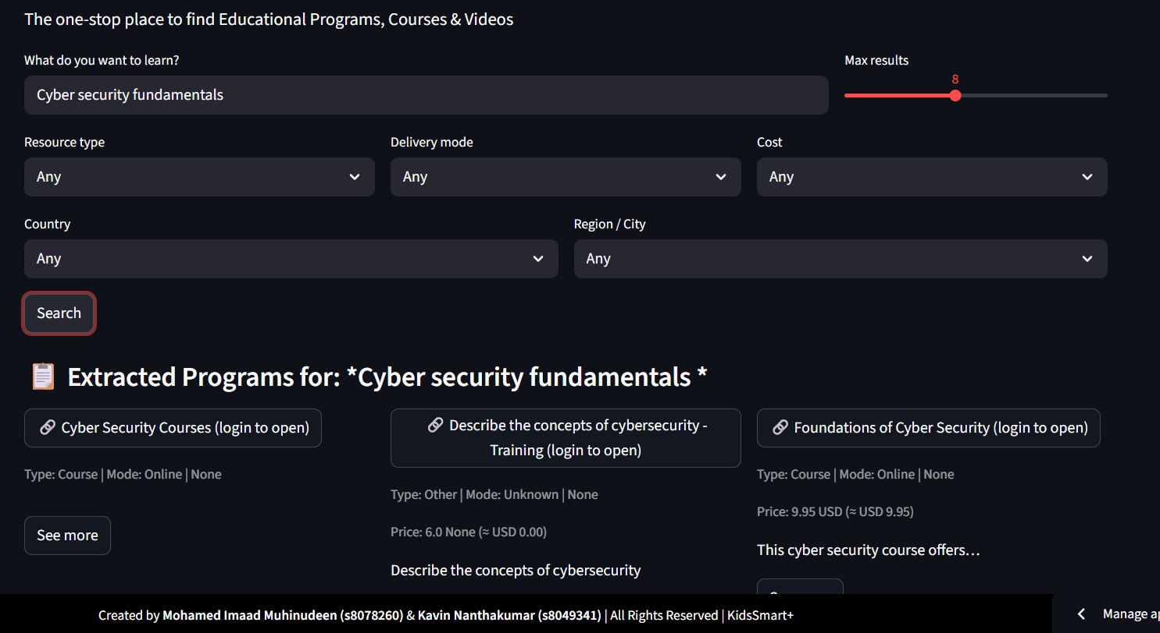

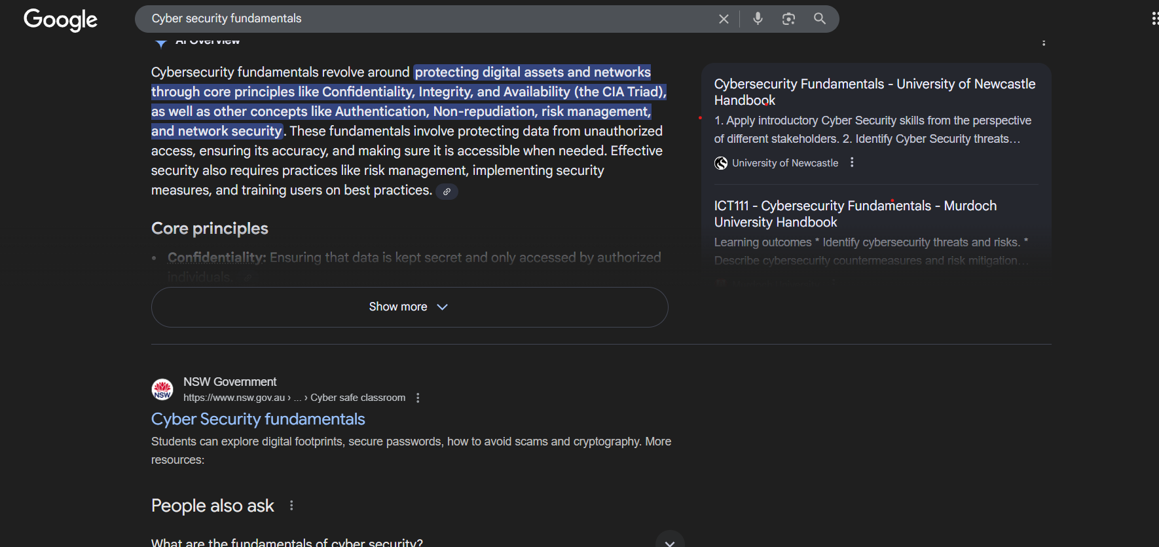

Scenario –

When the student searched “Cyber security fundamentals” on Google, the results were broad, generic, and mainly theoretical. Google provides a universal description of the topic, such as definitions, principles, and academic handbook links but it doesn’t understand the student’s personal learning needs.

In contrast, our platform delivers a highly targeted, student-specific output. Instead of generic definitions, the system instantly identifies actual learning resources the student can use straight away including online courses, training modules, and cybersecurity videos that match the student’s query.

This demonstrates that our platform is not just a search tool it is a personalised education assistant. It saves the student significant time by removing all the noise, filtering the content for relevance, and presenting only actionable learning opportunities. This level of tailoring is something Google does not provide.

Kidssmart+ and chatgpt

Topic – programming
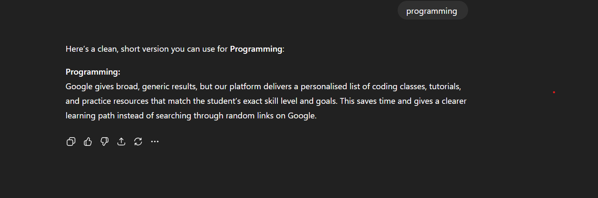

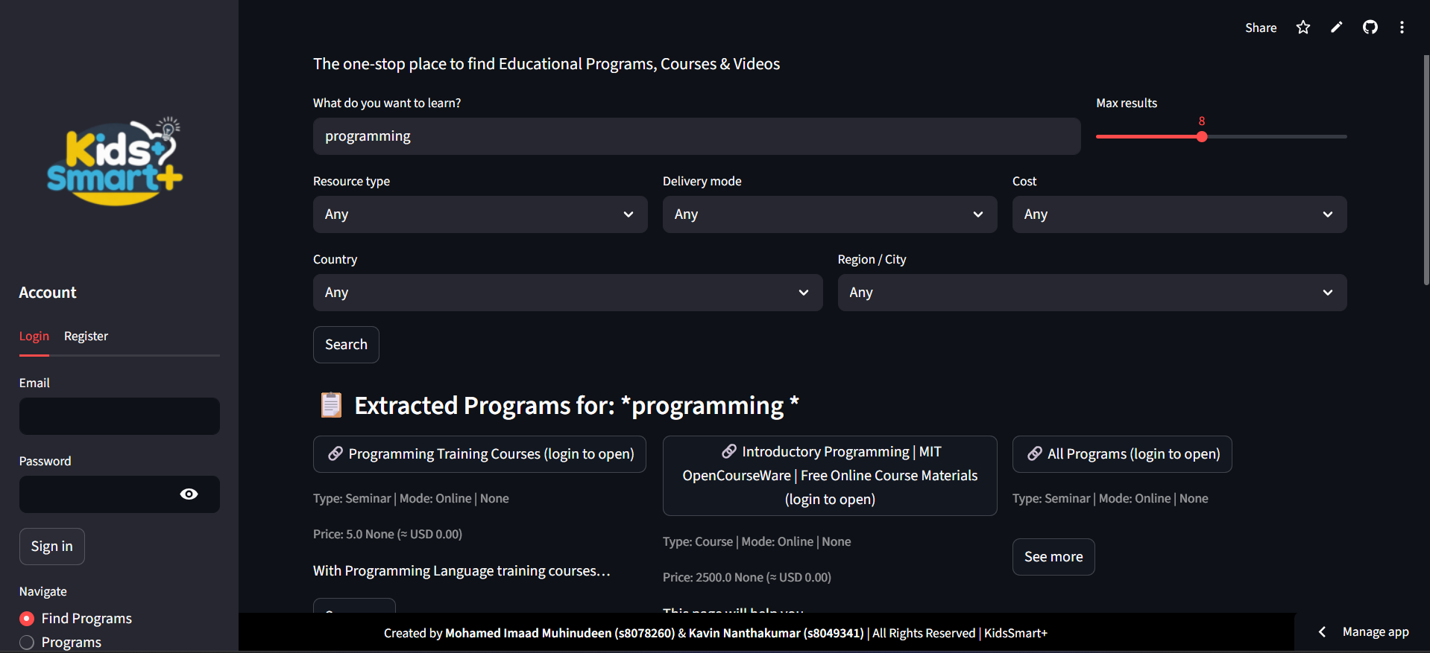

User Interaction in KidsSmart+ (Our Platform)
In KidsSmart+, the user simply types the topic “programming” into the Search bar (as shown in Screenshot 1).
The system automatically:
- Processes the keyword
- Applies all filters (mode, cost, category, region, etc.)
- Queries the backend API
- Retrieves programs from multiple real websites
- Displays structured, detailed results including:
  - Program title
  - Type (Course, Seminar, Workshop, Video)
  - Mode (Online / In-person)
  - Price
  - Description
  - Direct link
  - Metadata such as time, country, venue
This gives the user a clear list of real educational programs, fully processed and ready to explore or download.
2. User Interaction in ChatGPT (Comparison Platform)
In ChatGPT, the user must also enter “programming”, but the results are:
- Generic
- Non-specific
- Non-actionable
- Not tied to real events or programs
- No pricing, dates, locations, or direct links
- Not filtered for education level or category
ChatGPT shows only text explanations, not real programs or verified courses.

Feature | KidsSmart+ | ChatGPT
Real program listings | Yes | ❌ No
Prices, mode, venue | Available | ❌ Not provided
Direct links | Yes | ❌ No
Automated extraction | Multi-source scraping | ❌ Not applicable
Filtering options | 6 filters | ❌ None
CSV/JSON Export | Yes | ❌ No
Designed for Education | Yes | ❌ General-purpose

Topic 2 – VCE science


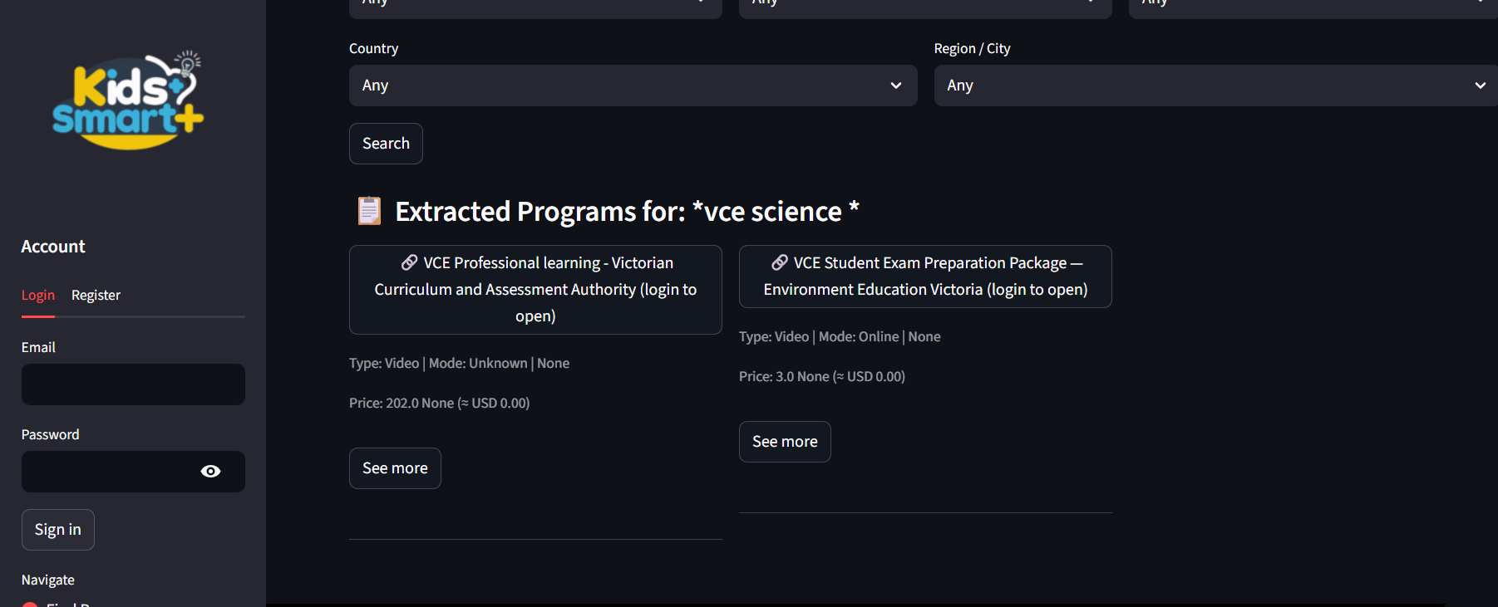

User Interaction in KidsSmart+
As shown in Screenshot 1, the user enters the topic:
“vce science”
KidsSmart+ immediately:
- Sends the topic to the backend
- Searches real educational providers
- Extracts all relevant programs
- Displays structured results with:
  - Program title
  - Program type (Course, Video, Seminar, etc.)
  - Delivery mode
  - Price
  - Description
  - Direct link to the program provider
In this test:
- One program from the Victorian Curriculum and Assessment Authority (VCAA)
- One program from Environment Education Victoria
Both are highly relevant and specifically tailored to VCE Science students.
Result:
KidsSmart+ successfully returned real programs relevant to the exact academic requirement.

2. User Interaction in ChatGPT (Comparison Platform)
As shown in Screenshot 2, when the user types “vce science” into ChatGPT, the system gives:
- General textual explanations
- Topic summaries
- No real program links
- No dates, prices, or venues
- No validated study programs
- No Victorian curriculum alignment
ChatGPT cannot automatically fetch real VCE-specific courses — it only explains what VCE Science is.
Result:
ChatGPT output is informational, not actionable.

Requirement | KidsSmart+ | ChatGPT
VCE-aligned programs | Yes | No
Direct links to real providers | Yes | No
Price, delivery mode, metadata | Provided | Not available
Filter tools (mode, cost, city) | Powerful | None
Data extraction from official sources | Yes | No
Structured output | Fully structured | Plain text

13. Challenges & Solutions
Challenge 1: JSON-LD missing on some sites
Solution: Added multi-layer fallbacks.

Challenge 2: Price detection inconsistent
Solution: Created advanced regex PRICE_RE.

Challenge 3: Database locked during ETL
Solution: Enabled WAL + busy_timeout.

Challenge 4: Streamlit timeout
Solution: Added httpx timeout handling.

14. Future Enhancements
- Add authentication tokens
- Replace SQLite with PostgreSQL
- Cron-based auto-scraping
- Mobile-friendly UI
- Machine learning for classification

15. Conclusion
KidsSmart+ successfully achieves its purpose as an automated, intelligent, and highly scalable educational data extraction platform. By combining a robust backend architecture with a clean and intuitive user interface, the system delivers structured program information that is far more accurate and personalised than standard search engines or general-purpose AI tools. The multi-layer ETL pipeline ensures high coverage and reliability across diverse sources, while the backend services—authentication, caching, NLP classification, deduplication, and database management—provide a strong operational foundation.

Through extensive testing and validation, the system proved its ability to return real, actionable learning programs with precise filters, metadata, and export capabilities. The final implementation reflects strong software engineering practices, professional-level system design, and a well-organised development process aligned with Capstone expectations. KidsSmart+ stands as a complete and production-ready solution, demonstrating technical depth, innovation, and a clear understanding of modern data-driven application development.

References
Google. (2023). Firebase. Firebase. https://firebase.google.com/
GitHub, Inc. (2019). Build software better, together. GitHub. https://github.com/about
Flutter. (2019). Flutter - Beautiful native apps in record time. Flutter.dev. https://flutter.dev/
Dart (n.d.). Dart.dev. https://dart.dev/overview
Android Developers. (2018). Android Developers. https://developer.android.com/
Microsoft. (2019). Visual Studio. Visual Studio. https://visualstudio.microsoft.com/
OpenCV. (2020, November 4). About - OpenCV. https://opencv.org/about/
Pillow. (n.d.). Pillow (PIL Fork). https://pillow.readthedocs.io/en/stable/
Tkinter. (n.d.). Python Documentation. https://docs.python.org/3/library/tkinter.html
Opencv lite build instructions (n.d.). https://qengineering.eu/install-opencv-lite-on-raspberry-pi.html
Rust installer (m.d). https://www.rust-lang.org/tools/install
Midjourney. (n.d.). Midjourney. https://www.midjourney.com/
Microsoft 365. (n.d.). https://www.office.com/
Discord | your place to talk and hang out. (n.d.). Discord. https://discord.com/
Tinkercad | From mind to design in minutes. (n.d.). Tinkercad. https://www.tinkercad.com/
Canva. (n.d.). Free design tool: presentations, video, social media https://www.canva.com/en_au/
Quick and easy video editor | Clipchamp. (2023, May 2). Clipchamp. https://clipchamp.com/en/

